Website Report for [www.newcastle-hospitals.nhs.uk](http://www.newcastle-hospitals.nhs.uk/)



The HOTH

111 2nd Ave NE, Suite 1500, St. Petersburg, FL 33701

877-720-4684

[support@thehoth.com](mailto:support@thehoth.com)

[thehoth.com](http://thehoth.com/)

This report grades your website based on the strength of various SEO factors such as On Page Optimization, O Page Links, Social and more. The overall Grade is on a A+ to F- scale, with most major, industry leading websites in the A range. Improving your grade will generally make your website perform better for users and rank better in search engines. There are recommendations for improving your website at the bottom of the report. Feel free to reach out to us if you’d like us to help with improving your website’s SEO!

Audit Results for [www.newcastle-hospitals.nhs.uk](http://www.newcastle-hospitals.nhs.uk/)



**A**

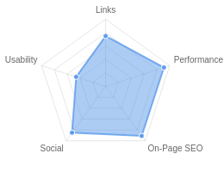**Your page is good**

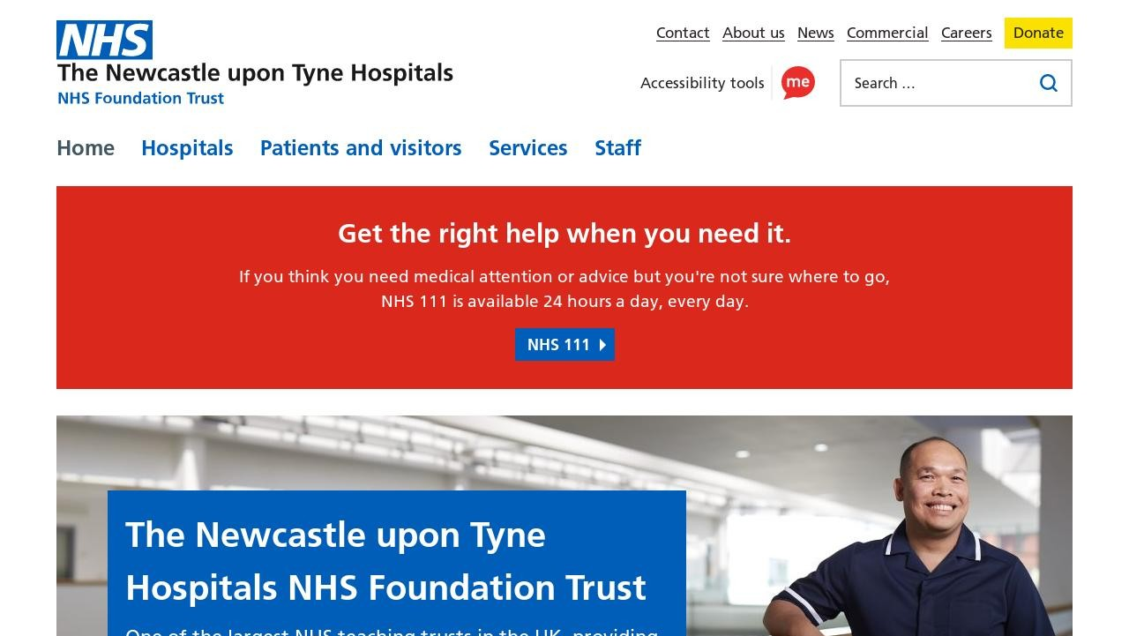

Recommendations: 9



**A+**



**A-**



**C**



**A+**



**A+**

On-Page SEO

Links

Usability

Performance

Social

Recommendations

# Shorten meta description (to between 70 and 160 characters)

On-Page SEO

Medium Priority

**Update Link URLs to be more human and Search Engine readable**

Links

Low Priority

# Optimize your page for Mobile PageSpeed Insights

Usability

Low Priority

**Optimize your page for Desktop PageSpeed Insights**

Usability

Low Priority

# Setup & Install a Facebook Pixel

Social

Low Priority

**Remove inline styles**

Performance

Low Priority

# Add Local Business Schema

Other

Low Priority

**Review and Increase Font Sizes across devices**

Usability

Low Priority

# Improve the size of tap targets

Usability

Low Priority

On-Page SEO Results

**Your On-Page SEO is very good!**



**A+**

Congratulations, your On-Page SEO is well optimized. On-Page SEO is important to ensure Search Engines can understand your content appropriately and help it rank for relevant keywords. You can continue to build on your strong position through testing content improvements for gradual gains.

# Title Tag

You have a title tag of optimal length (between 10 and 70 characters). Newcastle Hospitals NHS Foundation Trust

Length : 40

# Meta Description Tag

Your page has a meta description tag however, your meta description should ideally be between 70 and 160 characters (including spaces).

The Newcastle upon Tyne Hospitals NHS Foundation Trust is one of the largest NHS trusts in the UK providing healthcare to communities across the North East of England and beyond.

Length : 178

A meta description is important for search engines to understand the content of your page, and is often shown as the description text blurb in search results.

# SERP Snippet Preview

This illustrates how your page may appear in Search Results. Note, this is intended as a guide and Search Engines are more frequently generating this content dynamically.

[https://www.newcastle-hospitals.nhs.uk](http://www.newcastle-hospitals.nhs.uk/) ⋮

Newcastle Hospitals NHS Foundation Trust

The Newcastle upon Tyne Hospitals NHS Foundation Trust is one of the largest NHS trusts in the UK providing healthcare to communities across the ...

# Hreflang Usage

Your page is not making use of Hre ang attributes.

# Language

Your page is using the lang attribute. Declared: en-GB

# H1 Header Tag Usage

Your page has a H1 Tag.

# H2-H6 Header Tag Usage

Your page is making use multiple levels of Header Tags.

Header Tag Frequency

H2 14

H3 5

H4 0

H5 0

H6 0

# Keyword Consistency

Your page's main keywords are distributed well across the important HTML tags.

Individual Keywords

Keyword Title Meta Description

Tag

Headings Tags Page Frequency

hospitals    10

newcastle    8

news    8

nhs    7

visit    6

february    6

posted    5

please    5

Phrases

Phrase Title Meta Description

Tag

please visit    4

Headings Tags Page Frequency

category news    4

tyne hospitals nhs    3

hospitals nhs foundation

newcastle upon

tyne







3

*   3

nhs foundation trust

details please    3

*   3

february 2024    3

# Amount of Content

Your page has a good level of textual content, which will assist in it's ranking potential. Word Count: 518

# Image Alt Attributes

You do not have any images missing Alt attributes on your page.

# Canonical Tag

Your page is using the Canonical Tag.

https://[www.newcastle-hospitals.nhs.uk/](http://www.newcastle-hospitals.nhs.uk/)

# Noindex Tag Test

Your page is not using the Noindex Tag which prevents indexing.

# Noindex Header Test

Your page is not using the Noindex Header which prevents indexing.

# SSL Enabled

Your website has SSL enabled.

# HTTPS Redirect

Your page successfully redirects to a HTTPS (SSL secure) version.

# Robots.txt

Your website appears to have a robots.txt le.

<http://www.newcastle-hospitals.nhs.uk/robots.txt>

# Blocked by Robots.txt

Your page does not appear to be blocked by robots.txt.

# XML Sitemaps

Your website appears to have an XML sitemap.

https://[www.newcastle-hospitals.nhs.uk/sitemap_index.xml](http://www.newcastle-hospitals.nhs.uk/sitemap_index.xml)

# Analytics

Your page is using an analytics tool.



Google Analytics

# Schema.org Structured Data

You are using JSON-LD Schema on your page.

Rankings

# Top Keyword Rankings

This shows your top 10 Keyword Rankings in the speci c location. The list is ordered by the keywords that drive the most tra c to your page.

Keyword Country & Language

Position Total Searches Estimated Tra c



cardiac rhythm

management

EN

1

40,500

12,312

freeman  EN 7 450,000 11,520



freemen EN 9 450,000 6,750

freeman hospital  EN 1 22,200 6,748



freeman's hospital EN 1 22,200 6,748

newcastle freeman hospital

 EN 1 22,200 6,748



royal victoria in rmary EN 1 14,800 4,499

rvi  EN 1 14,800 4,499



efudix cream EN 1 12,100 3,678

newcastle rvi  EN 1 12,100 3,678

# Total Traffic From Search

This shows you the Estimated Tra c Volume your page receives from it’s Keyword Rankings



**663,871**

Monthly Tra c Volume

# Keyword Positions

This shows you a summary of the positions for your Keyword Rankings. The higher you rank, the more likely you are to capture tra c, with recent research showing that as much as 92% of clicks happen on the rst page.

Position Keywords

Position 1 1,010

Position 2-3 1,101

Position 4-10 5,096

Position 11-20 10,106

Position 21-30 10,484

Position 31-100 75,358

Links

# Backlink Summary

You have a very strong level of backlink activity to this page.



**75**



**28**

Domain Strength

Page Strength





**9.2k**

Backlinks

**2k**

Referring Domains

|  |  |  |  |  |  |
| --- | --- | --- | --- | --- | --- |
| **2.5k**  Nofollow Backlinks | **6.7k**  Dofollow Backlinks | **4**  Edu Backlinks | **73**  Gov Backlinks | **941**  Subnets | **1.3k**  IPs |

# Top Backlinks

These are the highest value external pages we have found linking to your site.

Domain strength

Referring Page URL

100 https://en.wikipedia.org/wiki/Freeman_Hospital

97 https://[www.theguardian.com/society/2023/dec/17/millions-of-women-are-su](http://www.theguardian.com/society/2023/dec/17/millions-of-women-are-su) ering-who-dont-h ave-to-why-its-time-to-end-the-misery-of-utis

97

https://[www.gov.uk/government/publications/climate-change-applying-all-our-health/climate-and](http://www.gov.uk/government/publications/climate-change-applying-all-our-health/climate-and)

-health-applying-all-our-health

96 https://[www.bbc.com/news/health-66917025](http://www.bbc.com/news/health-66917025)

96 https://[www.bbc.co.uk/news/health-66917025](http://www.bbc.co.uk/news/health-66917025)

96 https://[www.bing.com/images/search?&q=Newcastle+Lighthouse&qft=+](http://www.bing.com/images/search?&q=Newcastle%2BLighthouse&qft=%2B) lterui:color2-FGcls_WHIT E&FORM=IRFLTR

96 <http://edition.cnn.com/2002/WORLD/europe/03/05/britain.baby/index.html>

96 https://[www.nmr.mgh.harvard.edu/lab/omi](http://www.nmr.mgh.harvard.edu/lab/omi)

94 https://[www.nhs.uk/Services/Hospitals/MapsAndDirections/DefaultView.aspx?id=1232](http://www.nhs.uk/Services/Hospitals/MapsAndDirections/DefaultView.aspx?id=1232)

94 https://us1.campaign-archive.com/?u=ddc5e0856b1d6d300a1b0b227&id=a9858e46a3

# Top Pages by Backlinks

These are the pages on your site with the most the backlinks from other sites.

URL Backlinks

<http://www.newcastle-hospitals.nhs.uk/> 1,571

https://[www.newcastle-hospitals.nhs.uk/](http://www.newcastle-hospitals.nhs.uk/) 1,130

https://[www.newcastle-hospitals.nhs.uk/hospitals/institute-of-transpla...](http://www.newcastle-hospitals.nhs.uk/hospitals/institute-of-transpla) 492

https://[www.newcastle-hospitals.nhs.uk/help/privacy/](http://www.newcastle-hospitals.nhs.uk/help/privacy/) 464

https://[www.newcastle-hospitals.nhs.uk/hospitals/royal-victoria-in](http://www.newcastle-hospitals.nhs.uk/hospitals/royal-victoria-in) rm... 270

<http://newcastle-hospitals.nhs.uk/> 256

https://[www.newcastle-hospitals.nhs.uk/hospitals/freeman-hospital/](http://www.newcastle-hospitals.nhs.uk/hospitals/freeman-hospital/) 237

https://[www.newcastle-hospitals.nhs.uk/content/uploads/2020/10/TVCCN_I...](http://www.newcastle-hospitals.nhs.uk/content/uploads/2020/10/TVCCN_I) 224

https://[www.newcastle-hospitals.nhs.uk/about/trust/statutory-documenta...](http://www.newcastle-hospitals.nhs.uk/about/trust/statutory-documenta) 146

https://[www.newcastle-hospitals.nhs.uk/about/trust/vision-mission/](http://www.newcastle-hospitals.nhs.uk/about/trust/vision-mission/) 122

# Top Anchors by Backlinks

These are the top pieces of Anchor Text we found used to link to your site.

Anchor Backlinks

Go Now 853

Freeman Hospital 705

<http://www.newcastle-hospitals.nhs.uk/> 334

The Newcastle upon Tyne Hospitals NHS Foundation Trust's privacy notice (open 451 s in a new tab)

http://www.newcast 328

Newcastle Hospitals logo 314

newcastle-hospitals.nhs.u 239

Visit Hospital Website 235

Website 191

# Top Referring Domain Geographies

These are the Top Geographies we have found linking to your site.

Top TLDs Top Countries

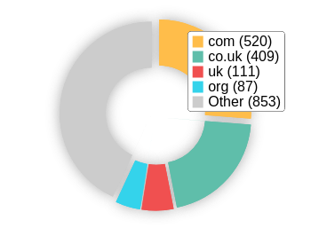 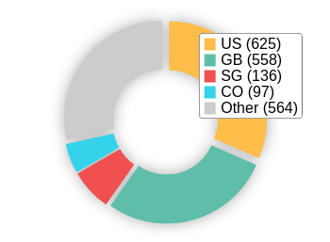

# On-Page Link Structure

We found 115 total links. 17% of your links are external links and are sending authority to other sites. 1% of your links are nofollow links, meaning authority is not being passed to those destination pages.

# Friendly Links

Some of your link URLs do not appear friendly to humans or search engines.

We would recommend making URLs as readable as possible by reducing length, le names, code strings and special characters.

Usability

# Your usability could be better



**C**

Your page is OK but could be more usable across devices. Usability is important to maximize your available audience and minimize user bounce rates (which can indirectly a ect your search engine rankings).

# Device Rendering

This check visually demonstrates how your page renders on di erent devices. It is important that your page is optimized for mobile and tablet experiences as today the majority of web tra c comes from these sources.

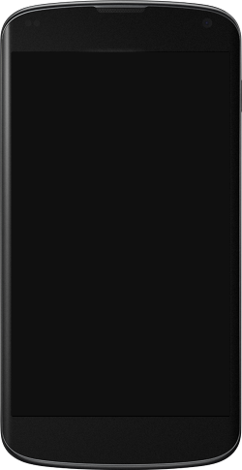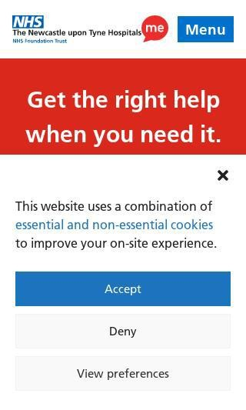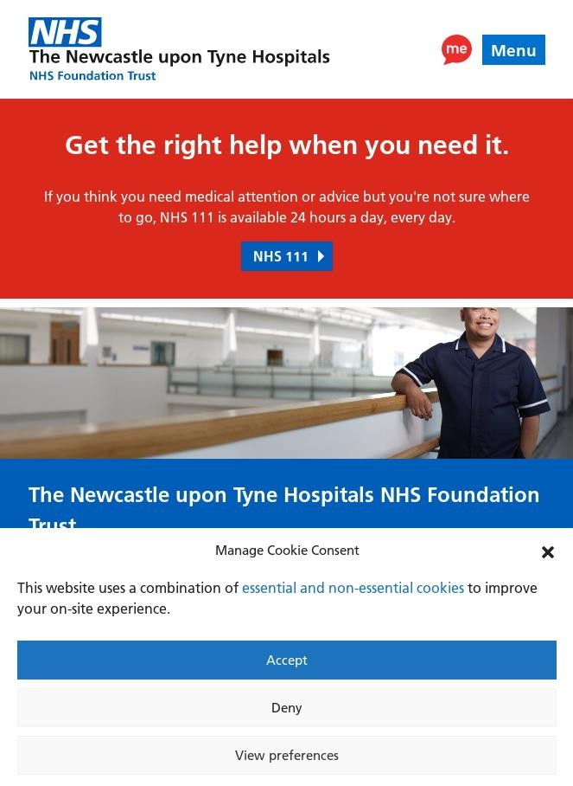

# Google's Core Web Vitals

Your page has passed Google's Core Web Vitals assessment.

Largest Contentful Paint (LCP)

First Input Delay (FID)

Cumulative Layout Shift (CLS)

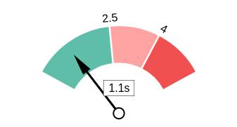 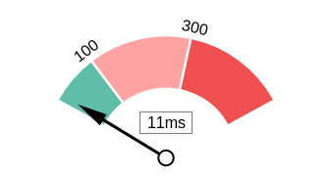 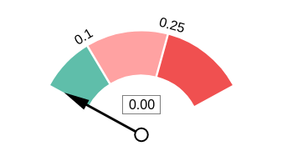

# Use of Mobile Viewports

Your page speci es a viewport matching the device's size, allowing it to render appropriately across devices.

# Google's PageSpeed Insights - Mobile

Google is indicating that your page is scoring poorly on their Mobile PageSpeed Insights evaluation.

Note that this evaluation is being performed from US servers and the results may di er slightly from an evaluation carried out from Google's PageSpeed Web Interface as that reporting localizes to the region in which you are running the report.

Google has indicated that the performance of a webpage is becoming more important from a user and subsequently ranking perspective.



**36**

Lab Data Value

First Contentful Paint 3.1 s

Reduce unused JavaScript

4.08 s

Opportunities Estimated Savings

Speed Index 7.7 s

Largest Contentful Paint 8.9 s

Time to Interactive 9.5 s

Total Blocking Time 0.82 s

Cumulative Layout Shift 0.006

Reduce initial server response time

Serve images in next-gen formats

Avoid multiple page redirects 0.63 s

Reduce unused CSS 0.4 s

1 s

0.45 s

Minify JavaScript 0.3 s

# Google's PageSpeed Insights - Desktop

Google is indicating that your page is scoring poorly on their Desktop PageSpeed Insights evaluation.

Google has indicated that the performance of a webpage is becoming more important from a user and subsequently ranking perspective.



**68**

# Flash Used?

No Flash content has been identi ed on your page.

Opportunities Estimated Savings

Reduce initial server response

time

1.01 s

Reduce unused JavaScript 0.69 s

|  |  |
| --- | --- |
| Lab Data | Value |
| First Contentful Paint | 2.1 s |
| Speed Index | 3.1 s |
| Largest Contentful Paint | 2.8 s |
| Time to Interactive | 2.9 s |
| Total Blocking Time | 0.04 s |
| Cumulative Layout Shift | 0.002 |

Avoid multiple page redirects 0.19 s



# iFrames Used?

There are no iFrames detected on your page.

# Favicon

Your page has speci ed a favicon.

# Email Privacy

No email addresses have been found in plain text on your page.

# Legible Font Sizes

There is some text on your page that is small and may not be legible enough for particular users.

We recommend reviewing all text on your page in di erent devices to ensure that it is of appropriate size.

# Tap Target Sizing

Some of the links or buttons on your page may be too small for a user to easily tap on a touchscreen. Consider making these tap targets larger to provide a better user experience.

Performance Results

# Your performance is very good!



**A+**

Congratulations, your page has performed very well in our testing meaning it should be reasonably fast and responsive for users. Performance is important to ensure a good user experience, and reduced bounce rates (which can also indirectly a ect your search engine rankings). Continue to monitor your performance over time to ensure there are no periodic uctuations.

# Page Speed Info

Your page loads in a reasonable amount of time.

Server Response All Page Content Loaded All Page Scripts Complete

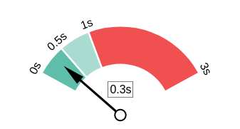 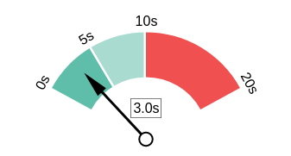 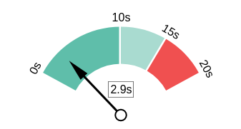

# Download Page Size

Your page's le size is reasonably low which is good for Page Load Speed and user experience.

Download Page Size Download Page Size Breakdown

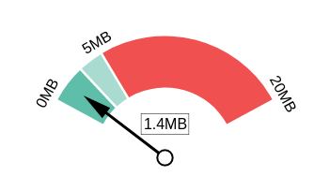 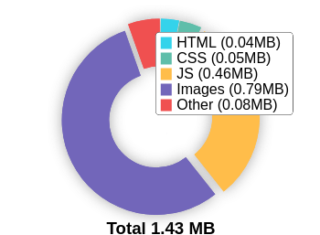

# Website Compression (Gzip, Deflate, Brotli)

Your website appears to be using a reasonable level of compression.

Compression Rates Raw Page Size Breakdown

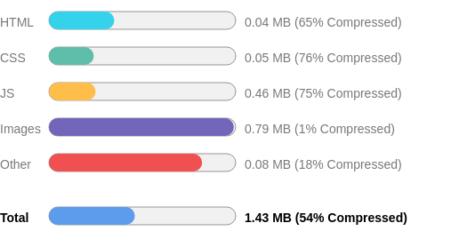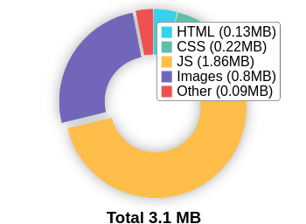

# Number of Resources

This check displays the total number of les that need to be retrieved from web servers to load your page.



**68**

Total Objects

**5**

Number of HTML Pages

**12**

Number of JS Resources

**8**

Number of CSS Resources

**35**

Number of Images

**8**

Other Resources

# Google Accelerated Mobile Pages (AMP)

This page does not appear to have AMP Enabled.

# JavaScript Errors

Your page is not reporting any JavaScript errors.

# HTTP2 Usage

Your website is using the recommended HTTP/2+ protocol.

# Optimize Images

All of the images on your page appear to be optimized.

# Minification

All your JavaScript and CSS les appear to be mini ed.

# Deprecated HTML

No deprecated HTML tags have been found within your page.

# Inline Styles

Your page appears to be using inline styles.

Inline styles are an older coding practice and discouraged in favor of using CSS style sheets, due to their ability to degrade page load performance and unnecessarily complicate HTML Code.

Social Results

# Your social is very good!



**A+**

Congratulations, your social presence is strong and active. Social activity is important for customer communication, brand awareness and as a marketing channel to bring more visitors to your website. We recommend continued use of social campaigns to grow this further.

# Facebook Connected

Your page has a link to a Facebook Page.

# Facebook Open Graph Tags

Your page is using Facebook Open Graph Tags.

# Facebook Pixel

We have not detected a Facebook Pixel on your page.

Facebook's Pixel is a useful piece of analytics code that allows you to retarget visitors if you decide to run Facebook Ads in future.

# Twitter Connected

Your page has a link to a Twitter pro le.

# Twitter Cards

Your page is using Twitter Cards.

# Instagram Connected

Your page has a link to an Instagram pro le.

# LinkedIn Connected

Your page has a link to a LinkedIn pro le.

# YouTube Connected

Your page has a link to a YouTube channel.

# YouTube Activity

You have a good number of YouTube channel subscribers

 

**5,250**

Followers

**1,724,209**

View Count

Local SEO

# Local Business Schema

No Local Business Schema identi ed on the page.

# Google Business Profile Identified

A Google Business Pro le was identi ed that links to this website.



Newcastle Freeman Hospital

# Google Business Profile Completeness

The important business details are present on the Google Business Pro le.

Address Freeman Rd, High Heaton, Newcastle upon Tyne NE7 7DN

Phone +44 191 233 6161

Site

https://www.newcastle-

hospitals.nhs.uk/hospitals/freeman- hospital/

# Google Reviews

The Google Business Pro le has a good rating and review count.

4.3

★★★★★

403 reviews

Rating

5

4

3

2

1

Technology Results

# Technology List

These software or coding libraries have been identi ed on your page.

Technology Version



Cloud are

Cloud are Bot Management



Google Analytics

 Google Tag Manager

HTTP/3

 jQuery



MySQL

PHP



reCAPTCHA

 WordPress



WP Engine

Yoast SEO 22.0

# Server IP Address

141.193.213.21

# DNS Servers

nsc.nic.uk dns2.nic.uk dns3.nic.uk nsa.nic.uk nsd.nic.uk dns1.nic.uk nsb.nic.uk dns4.nic.uk

# Web Server

cloud are

# Charset

text/html; charset=UTF-8